Tao Ishizuka

10/21/2020

Dr. Kadar

Intro to Chem

Vitamin C Lab

**Objective:** The objective of this experiment is to use titration to calculate the ascorbic acid content in a Vitamin C tablet.

**Introduction:** Titration is a method where a [solution](https://www.chemicool.com/definition/solution.html) of unknown [concentration](https://www.chemicool.com/definition/concentration.html) is reacted with a solution of a known concentration in order to find out more about the unknown solutions molarity & solute mass. The unknown solutions molarity can be found by finding when the known and unknown solutions are equivalent (in mols). Taking the volume used for the known solution. because you already know the molarity of the known solution (NaOH), you can find the moles of solute for the known and unknown solution. With that information you can find the mass of ascorbic acid. The mass of ascorbic acid will be different from the mass of the tablet, this is because parts of tablets are made up of fillers that are not ascorbic acid.

**Procedure:** Preparing the Vitamin C Solutions .

1. Weigh three Vitamin C tablets and record the mass.
2. Crush the three Vitamin C tablets (The smaller the particle size, the easier the powder will dissolve.)
3. Weigh out about 0.5 g (±0.05g) powder into a weighing dish. Record all digits from the balance
4. Transfer the powder into a 250-mL Erlenmeyer flask. Rinse the weighing dish with water from a squeeze bottle into the Erlenmeyer flask.
5. Add about 40-50 mL water, and place the Erlenmeyer flask on a hot plate. Heat it gently, and swirl the content periodically.
6. Once no more of the powder is visibly dissolving, remove the flask from the hot (fillers don’t dissolve)

Setting up the Buret

1. Fill a 150-mL beaker about half with your standardized NaOH solution
2. Rinse the buret 3 times with few mL’s of the NaOH solution.
3. Mount the buret with a clamp on a stand, makingsure itis perpendicular to the benchtop.
4. Make sure stopcock is closed, then fill the buret with the NaOH stock solution, using a small funnel.
5. Have a waste beaker under the buret, open the stopcock, fill the buret tip, make sure there are no air bubbles left in the tip
6. Fill buret to right below or at the 0mL mark.
7. Remove any hanging drop before starting by touching the tip to the inner wall of the beaker
8. Read buret at bottom of meniscus at eye level and record the volume to the second decimal place to nearest 0.01 mL.

Performing a test trial

1. Place the flask with ascorbic acid & 2 drops of phenolphthalein solution under the buret.
2. Add 1 mL of NaOH solution at a time while continuously swirling the solution in the Erlenmeyer flask
3. When the solution turns light pink-purple, read the volume from the buret.
4. Calculate the amount of NaOH solution used and subtract 2 mL from it. This is the rough volume.

Performing the titration

1. Refill the buret with NaOH solution, read and record the initial reading.
2. Make solutions from the three samples in Erlenmeyer flasks with about 0.5 g (±0.05g) of tablet powder and 2 drops of phenolphthalein.
3. Place the first flask under the buret and add the calculated rough volume of NaOH in one shot, while swirling the solution in the Erlenmeyer flask
4. After the addition of the rough volume, continue to add the titrant one drop at a time while swirling the solution until the solution turns pale “baby-pink” (be very careful, add one drop at a time the reaction is extremely sensitive.)
5. Read and record the final reading.
6. Perform the titration with the 2 remaining samples.
7. When finished, rinse the buret and the Erlenmeyer flask well with distilled water 3 times. Discard the waste as instructed.
8. Record the amount of Vitamin C in the tablet from the label on the bottle.

**Data:** Vitamin C tablets

|  |  |  |  |
| --- | --- | --- | --- |
| **Mass of individual tablet (g)** | 1.2637 | 1.2845 | 1.2499 |
| **Total mass of three tablets (g)** | 3.7981 |
| **Average mass of Vitamin C tablet (g)** | 1.2660 |

Test Run

|  |  |
| --- | --- |
| **Mass of sample (g)** | .4955 |
| **Rough volume of NaOH standard (mL)** | (25.10 - 2.10) - 2.00 = 21.00 |

Trials

|  |  |  |  |
| --- | --- | --- | --- |
|  | **Trial 1** | **Trial 2** | **Trial 3** |
| **Concentration of NaOH (M)** | .1007 | .1007 | 1.007 |
| **Mass of sample (g)** | .5152 | .5102 | .4986 |
| **Initial buret reading (mL)** | .55 | .20 | 20.45 |
| **Final buret reading (mL)** | 25.20 | 24.55 | 44.05 |
| **Volume of NaOH (mL)** | 24.65 | 24.35 | 23.60 |
| **Amount of NaOH used in solution (mole)** | 2.482 x 10^-3 | 2.452 x 10^-3 | 2.377 x 10^-3 |
| **Amount of ascorbic acid in sample (mol)** | 2.482 x 10^-3 | 2.452 x 10^-3 | 2.377 x 10^-3 |
| **Mass of ascorbic acid in sample (g)** | .4371 | .4318 | .4186 |
| **Percent ascorbic acid content of sample (%)** | 84.8 | 84.6 | 84.0 |
| **Average ascorbic acid content of sample (%)** | 84.47 |  |  |
| **Average ascorbic acid content of a 1000-mg tablet (g)** | .8447 |  |  |
| **% error** | 15.53 |  |  |

**Calculations:** *Vitamin C tablets*



*Test Run*



*Balanced Equation*



*Trial 1*



**\**

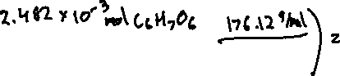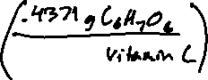

*Trial 2*

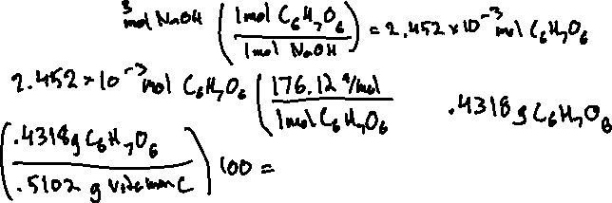

*Trial 3*

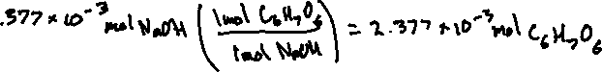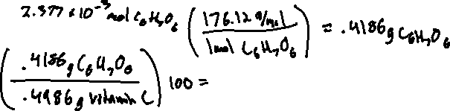

*Average ascorbic acid content of sample (%)*



*Average ascorbic acid content of a 1000-mg tablet (g)*



*% error*



**Discussion:** The purpose of finding all this data and doing the experiment is to find the content of ascorbic acid in the vitamin C tablet. Using the NaOH lab from last week we were given the molarity of NaOH (.1007M). Once you find out how much NaOH .1007M solution it takes to equivalence the NaOH and ascorbic acid, you will be able to figure out the ascorbic acid content in the solution with water and the vitamin C tablet. Once the volume of NaOH solution is found, convert it to liters and multiply the volume by .1007M. That will give you the number of mols of NaOH. Because in the chemical equation of the experiment NaOH and ascorbic has a 1:1 molar ratio, the number of moles found for NaOH is the same for ascorbic acid. With the number of moles, you can find the mass of how much ascorbic acid was in the sample. In trial 1 we started with a .5152g sample of vitamin C tablet, we calculated that .4371g ascorbic acid was in the tablet, giving trial 1 an 84.8% ascorbic acid content of sample. In trial 2 we started with a .5102g sample of vitamin C tablet, we calculated that .4318g ascorbic acid was in the tablet, giving trial 2 an 84.6% ascorbic acid content of sample. In trial 3 we started with a .4986 sample of vitamin C tablet, we calculated that .44186g ascorbic acid was in the tablet, giving trial 3 an 84.0% ascorbic acid content of sample. The average of the 3 trials was 84.47% ascorbic acid content. The percent ascorbic acid content is lower than 100 percent because tablets are made with fillers that are not ascorbic acid and contribute to sample mass, but don’t take part in the reaction during titration. Although the results were consistent they were not perfect due to factors of human error. Few examples of human error could be not dissolving the tablet into the water enough, reading the buret incorrectly, or over titrating.

**Conclusion:** In conclusion in this lab we learned how to use titration to calculate the content of ascorbic acid ina vitamin C tablet. The experiment was successful in that the, “percent ascorbic acid content of sample” was very consistent in each of the three trials.

**References:** Vitamin C Lab Manual