Determination of the Ascorbic Acid Content of a Vitamin Pill
- Preparing the Vitamin C Solutions
- Weigh three Vitamin C tablets, and record the data in the respective data table.
- Crush the three Vitamin C tablets in a mortar with a pestle.
Note: The smaller the particle size, the easier the powder will dissolve.
- Weigh out about 0.5 g (±0.05g) powder into a weighing dish. Record all digits from the balance.
- Transfer the powder into a 250-mL Erlenmeyer flask. Rinse the weighing dish with water from a squeeze bottle into the Erlenmeyer flask to ensure quantitative transfer.
- Add about 40-50 mL water, and place the Erlenmeyer flask on a hot plate.
- Heat it gently, and swirl the content periodically.
- Once no more of the powder is visibly dissolving, remove the flask from the hot plate.
Note: Some filler materials won’t dissolve. Do not boil the solution!

- Setting up the Buret
- Fill a 150-mL beaker about half with your standardized NaOH solution
- Rinse the buret 3 times with small portions (few mL’s) of the NaOH solution.
- Mount the buret with a clamp on a stand, making sure it is perpendicular to the benchtop. Note: The buret should be mounted by its lower third.
- Make sure stopcock is closed (perpendicular to the buret), then fill the buret with the NaOH stock solution, using a small funnel. The stock solution in the buret is the titrant.
Note: While filling buret, lift funnel to allow air to come out.
- Have a waste beaker under the buret, open the stopcock (parallel to the buret), and fill the buret tip, making sure there are no air bubbles left in the tip.
Note: Handle the stop cock on the buret gently. Too much force can eject the tip flooding the bench with NaOH solution. Also, stop the titration and call your instructor, if the stopcock leaks after opening it.
- Fill buret to about, but below the 0 mL mark.
- Remove any hanging drop before starting by touching the tip to the inner wall of the beaker (Figure 1).
- Read buret at bottom of meniscus at eye level and record the volume to the second decimal place to nearest 0.01 mL ()Figure 2.
- Position the tip of the buret inside the neck of the flask, but not touching the wall of the flask.
- Position a white paper towel so it is behind and underneath the flask for better contrast to observe the color change.
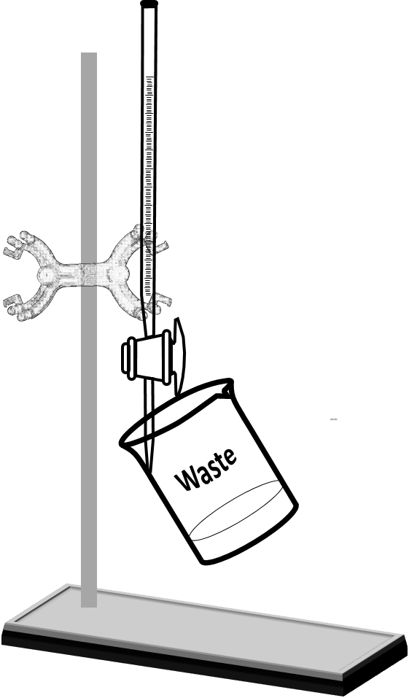 | 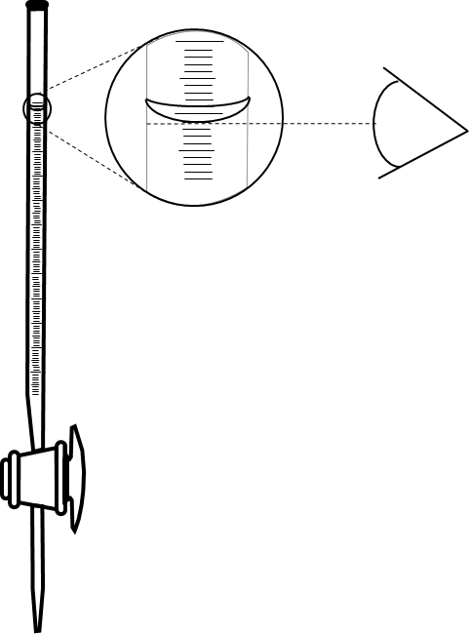
Figure 1. | Figure 2.

- Performing a test trial

- Place the flask under the buret.
- Add 1 mL of the titrant at a time while continuously swirling the solution in the Erlenmeyer flask (Figure 3).
- When the solution turns pink-purple, read the volume from the buret.
- Calculate the amount of NaOH solution used and subtract 2 mL from it. This is the rough volume.

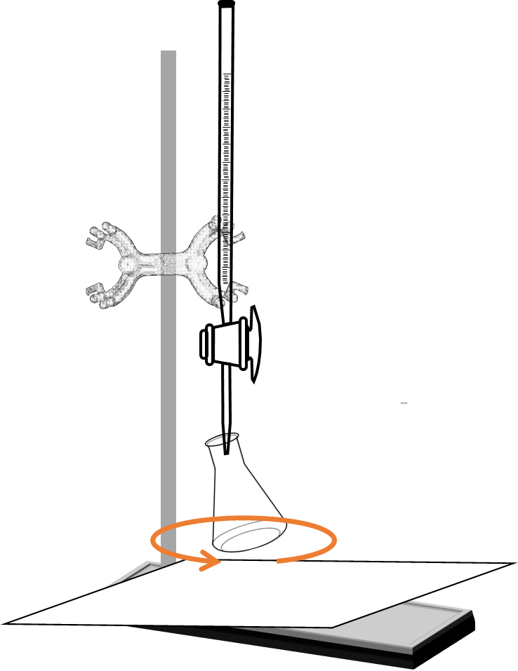 | 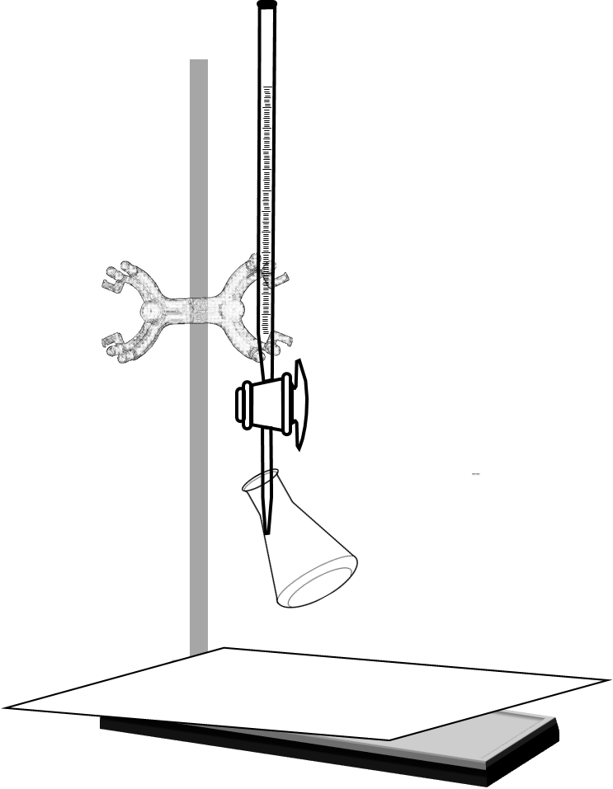
Figure 3. | Figure 4.

- Performing the titration

- Refill the buret, read and record the initial reading.
- Number three weighing dishes.
- Make solutions from the three samples in Erlenmeyer flasks just like in Part A. Number the flasks as well.
Note: Do not forget to add the phenolphthalein.
- Place the first flask under the buret and add the calculated rough volume of NaOH in one shot, while swirling the solution in the Erlenmeyer flask.
- After the addition of the rough volume, continue to add the titrant one drop at a time while swirling the solution until the solution turns pale “baby-pink”. This point is the end point.
Note: As the titration approaches the end point, the temporary purple color where the titrant hits the solution persists longer before the solution is thoroughly mixed. Near the end point, add half a drop by allowing half a drop hanging from the tip of the buret, and transferring the drop into the solution by touching the tip with the inner wall of the flask (Figure 4).
- Read and record the final reading.
- Perform the titration of the remaining two samples in the same way (D.1-6).
- When done, rinse the buret and the volumetric flask well with distilled water 3 times and return.
- Discard the waste as instructed.
- Record the amount of Vitamin C in the tablet from the label on the bottle.

- Calculations
Include the following calculations in the Results & Discussion part of the lab report:
  - Calculate the total mass and average for the Vitamin C tablets.
  - Calculate the volume of NaOH delivered for each trial.
  - Calculate the mass of Vitamin C for each trial.
  - Calculate the mass % of vitamin C in each sample.
  - Calculate the average mass % of vitamin C.
  - Calculate the average amount of Vitamin C in a 1000 mg tablet.
  - Calculate the % error.

- Data & Results Tables
Vitamin C Tablets
Mass of individual tablet
Total mass of three tablets
Average mass of a Vitamin C tablet

Test Run
Mass of sample
Rough volume of NaOH standard

Trials
 | Trial 1 | Trial 2 | Trial 3
Concentration of NaOH
Mass of sample
Initial buret reading
Final buret reading
Volume of NaOH
Amount of NaOH in used solution
Amount of ascorbic acid in sample
Mass of ascorbic acid in sample
Percent ascorbic acid content of sample
Average ascorbic acid content of sample
Average ascorbic acid content of a 1000-mg tablet
% error

- Post-lab Questions

- Why is the molar ratio between ascorbic acid and NaOH 1:1 in the titration reaction, even though the ascorbic acid has more hydrogen atoms?

- Why is the average mass of the three tablets calculated instead of just weighing a single tablet?

- Why is it important not to boil the Vitamin C solution?

- Why could the amount of water used to make the Vitamin C solutions be approximated instead of measuring it out accurately?

- Why was the ascorbic acid content for each trial calculated first, then averaged, instead of calculating the average volume of the titrant used in the three trials first, then calculating the ascorbic acid content from the average volume?

- Why do you think the average % ascorbic acid content is significantly less than 100%?

