Preparation and Standardization of 0.1 M NaOH solution
- Preparing the NaOH Solution
- Tare a small beaker on a balance, and weigh out the calculated amount of NaOH as close as using whole pellets allows.
Note: Minimize the exposure of the NaOH pellets to air, because it quickly absorbs moisture (hygroscopic) and CO₂. Don’t break up the pellets, the exact concentration of the NaOH solution will be determined by the titration. Make sure to close the NaOH container when done.
- Rinse the surface of the pellets with a small amount of distilled water to remove any sodium carbonate that formed on the pellets and discard the washing into your waste beaker (Figure 1). Add about 30-40 mL distilled water to the beaker containing the NaOH pellets, and swirl/stir to make a solution.
- Transfer the solution into a 500-mL volumetric flask. Rinse the beaker and stir rod a few times with small portions of distilled water and transfer to the flask, then fill the flask to the mark with distilled water. Close the opening of the flask with a cap, stopper, or piece of Parafilm, depending on the type of volumetric flask. Hold the top with your thumb, and mix the solution thoroughly by inverting the flask a few times.
Note: First fill the flask up to about an inch below the mark from a distilled water jug or squeeze bottle with the cap removed, then slowly fill to the mark with a disposable pipet.
- Transfer the solution into a plastic bottle.
- Fill a clean, dry 150-mL beaker about halfway with the solution, and cover it with a watch glass to keep moisture and CO₂ out. This is the stock solution.

- Setting up the Buret
- Rinse the buret 3 times with small portions (few mL’s) of the NaOH solution.
- Mount the buret with a clamp on a stand, making sure it is perpendicular to the benchtop. Note: The buret should be mounted by its lower third.
- Make sure stopcock is closed (perpendicular to the buret), then fill the buret with the NaOH stock solution, using a small funnel. The stock solution in the buret is the titrant.
Note: While filling buret, lift funnel to allow air to come out.
- Have a waste beaker under the buret, open the stopcock (parallel to the buret), and fill the buret tip, making sure there are no air bubbles left in the tip.
Note: Handle the stop cock on the buret gently. Too much force can eject the tip flooding the bench with NaOH solution. Also, stop the titration and call your instructor, if the stopcock leaks after opening it.
- Fill buret to about, but below the 0 mL mark.
- Remove any hanging drop before starting by touching the tip to the inner wall of the beaker (Figure 2).
- Read buret at bottom of meniscus at eye level (Figure 3) and record the volume to the second decimal place (to nearest 0.01 mL).
- Position the tip of the buret inside the neck of the flask, but not touching the wall of the flask.
- Position a white paper towel so it is behind and underneath the flask for better contrast to observe the color change.
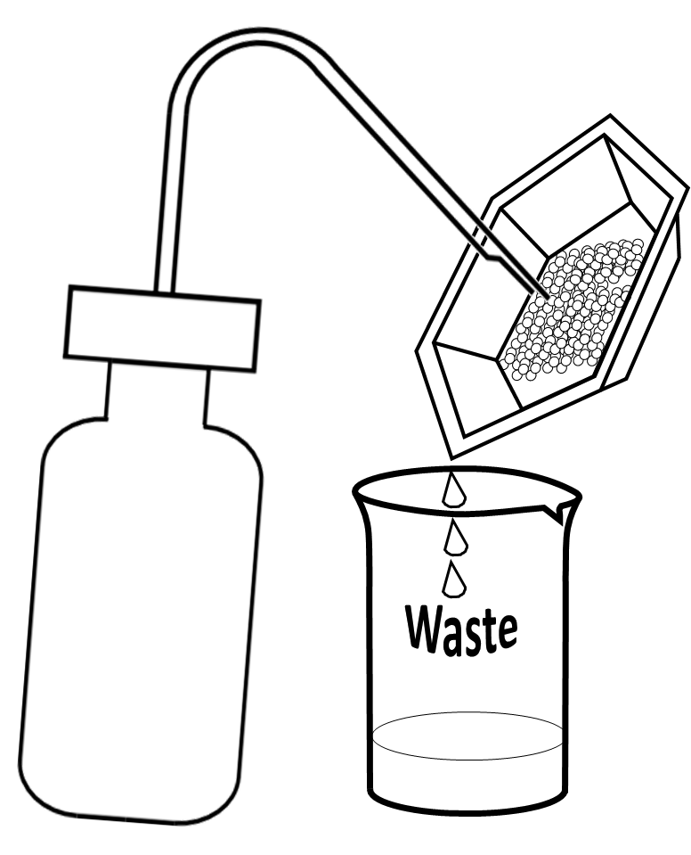 | 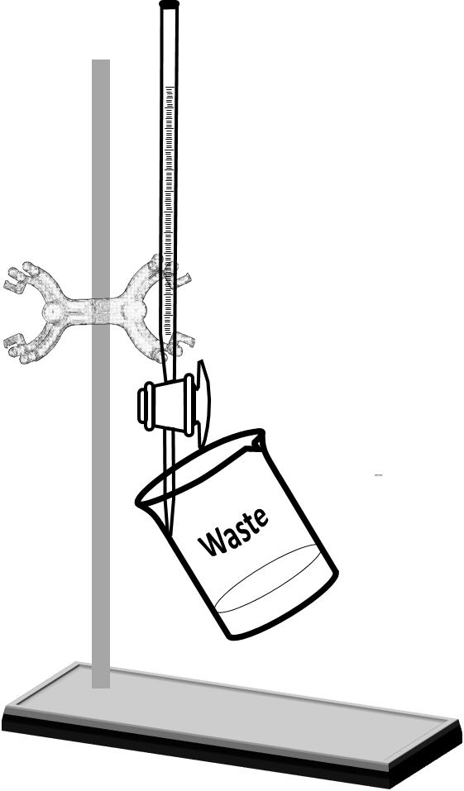
Figure 1. | Figure 2.

- Performing a test trial

- Weigh between 0.30 - 0.35 g potassium hydrogen phthalate (KHP) into a tared weighing dish, recording the exact mass dispensed.
Note: Exercise caution transporting the KHP from the balance room to the lab, preventing any loss of the sample.
- Transfer the crystals into a 250-mL Erlenmeyer flask, and rinse the dish with small portions of distilled water a few times into the Erlenmeyer flask to ensure quantitative transfer.
- Dissolve the crystals, adding enough water to have about ½”of solution in the flask.
- Add 1-2 drops of phenolphthalein indicator.
- Place the flask under the buret. Place a white sheet of paper under the flask for a better contrast.
- Add 1 mL of the titrant at a time while continuously swirling the solution in the Erlenmeyer flask (Figure 4).
Note: Titration is a single-person operation. Swirling the solution and operating the stopcock have to be performed by the same person.
- When the solution turns pink-purple, read the volume from the buret.
- Calculate the amount of NaOH solution used and subtract 2 mL from it. This is the rough volume.
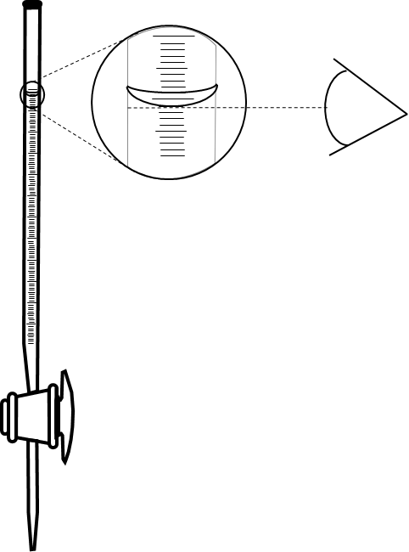 | 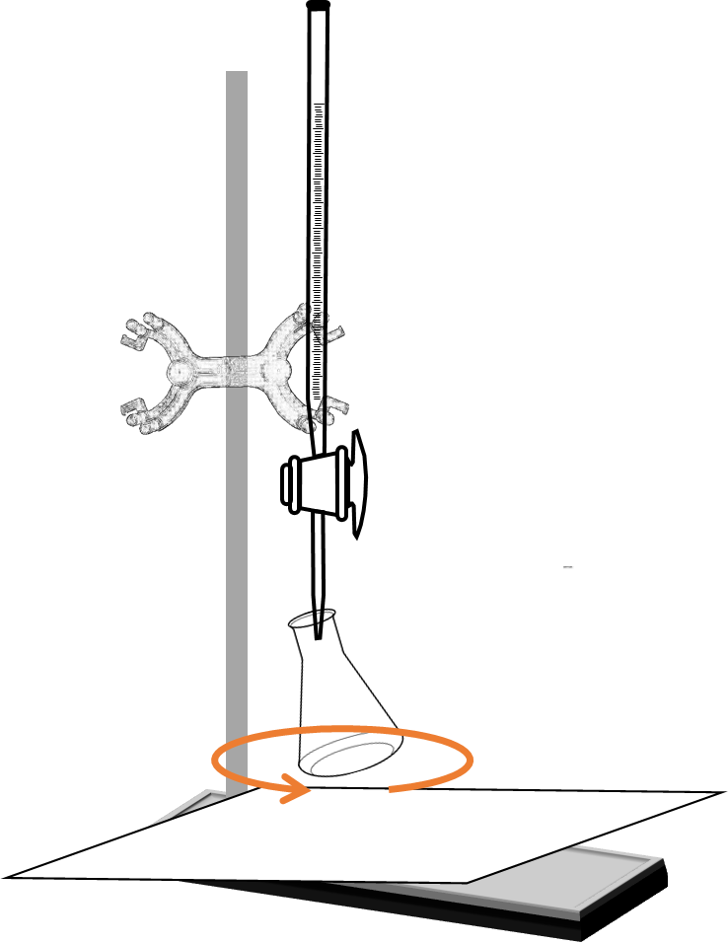
Figure 3. | Figure 4.

- Performing the titration

- Refill the buret, read and record the initial reading.
- Number three weighing dishes and weigh out between 0.30 - 0.35 g of KHP into each, recording the mass of each.
- Make solutions from the three samples in Erlenmeyer flasks just like before (C.2-4). Number the flasks as well.
Note: Do not forget to add the phenolphthalein.
- Place the first flask under the buret and add the calculated rough volume of NaOH in one shot, while swirling the solution in the Erlenmeyer flask.
- After the addition of the rough volume, continue to add the titrant one drop at a time while swirling the solution until the solution turns pale “baby-pink”. This point is the end point.
Note: As the titration approaches the end point, the temporary purple color where the titrant hits the solution persists longer before the solution is thoroughly mixed. Near the end point, add half a drop by allowing half a drop hanging from the tip of the buret, and transferring the drop into the solution by touching the tip with the inner wall of the flask and washing it down (Figure 5).
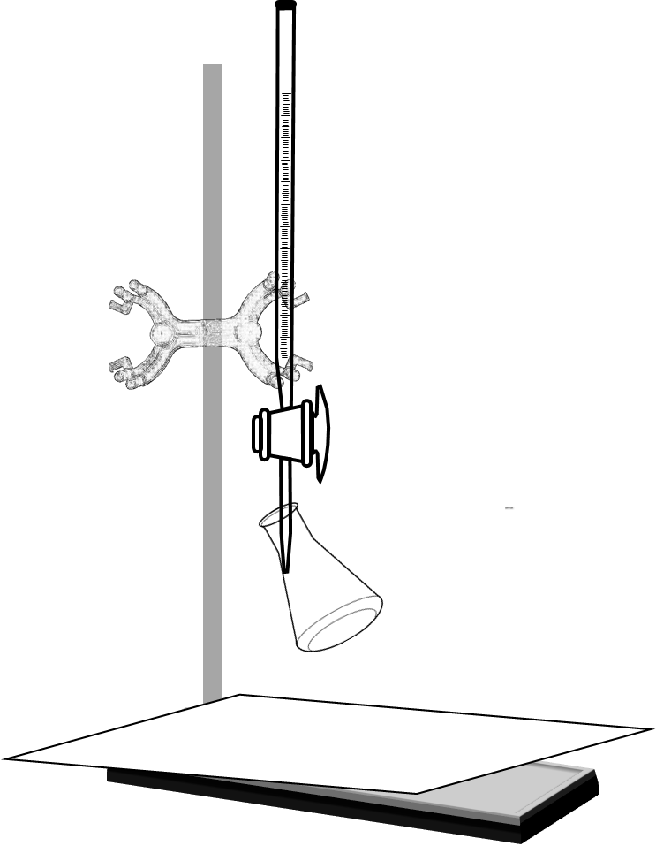
Figure 5

- Read and record the final reading.
- Perform the titration of the remaining two samples in the same way (D.1-6).
- Calculate the exact concentration of the stock solution.
- Label the plastic bottle, including the exact concentration. Collect the left over stock solution from the beaker and the buret, transfer it into the plastic bottle. Save the stock solution in your cabinet for the next lab.
Note: Generally, solutions/chemicals are NOT to be returned into the original container. Saving the unused titrant from the buret and the beaker is a precaution to make sure there will be enough titrant for the second part of the lab.
- When done, rinse the buret and the volumetric flask well with distilled water 3 times and return.
- Discard the waste as instructed.

Post Lab Questions
- After rinsing the buret with water, why was it rinsed three times with the NaOH solution before filling the buret with the solution? How would this affect your final molarity of NaOH, if you forgot to do this?

- Does the amount of water used to dissolve the KHP affect the molarity of the NaOH solution? Explain.

- Why do you think you have to run three trials instead of just one?

- When filling the buret with NaOH solution, an air bubble was left in the buret tip. The bubble was released during the first titration. How would this affect the molarity of the NaOH solution? Explain.

- After completing the titration, droplets of titrant were clinging to the inner wall of the buret. How would this affect the molarity of the NaOH solution? Explain.

- After completing the titration, a droplet of titrant was hanging on the tip of the buret. How would this affect the molarity of the NaOH solution? Explain.

- Why do you think you were instructed to add only a half of a droplet close to the equivalence point?

- Typically the average of the volumes for the three trials is calculated, from which the molarity is calculated. Why did you have to calculate first the molarity for each trial and average the molarity values?

Pre Lab Questions
- What kind of reaction is between NaOH and KHP?

- What is the role of phenolphthalein in the titration?

- Why was it important to keep carbon dioxide out of the NaOH solution? How would the absorption of carbon dioxide affect your final molarity of NaOH?

- NaOH is very hygroscopic. How do you think the absorbed water by the NaOH pellets would affect the final molarity?

- Why is KHP a good agent to standardize the NaOH solution?

- Which reactant, if any, is in access in the Erlenmeyer flask before the equivalence point?

- Which reactant, if any, is in access in the Erlenmeyer flask at the equivalence point?

- A titration attempt ended up with a deep magenta color in the Erlenmeyer flask. Which reactant, if any, is in access?

- Based on your response to the last three questions explain how titration works.

